Development Planning and Management/ Project Development & Planning

1
Planning

Objectives

After this discussion, participants are expected to:
1. Define what planning is and what it is all about
2. Identify and recognize the different theories and steps in planning
3. Formulate a vision and a strategy for a particular period of time
4. Evaluate the prevailing conditions in their respective localities

_____________________________________________________________________________

“To be prepared is half the victory”
- Miguel de Cervantes

A plan is very much different from planning. The former can be considered as a framework of realizing and or accomplishing something; a plan according to Bettelheim (1959, p.3) consists of the totality of arrangements decided upon in order to carry out a project, the idea of a plan is definable by two elements:
- A project, that is, an end which one proposes to achieve;
- The arrangements decided upon in order that this end may be achieved that is, the determination of the means.
“A determined end and means, equally determined, for the attainment of this end, constitute the essence of every plan; and this is what in particular distinguishes a plan from a mere project” (Ibid, p.3).
Planning on the other hand is a process on how that something is to be realized or accomplished. Planning in most developed countries is very crucial in every aspect of organizational life both in the public and the private sector. In the US for example McClendon and Catanese (1996) argued that planning is an institution of American life that it is a process with principles, methods, and techniques, which planners lead the process. It is in this regard that planning deals with a body of knowledge which involves certain techniques and processes that is being crafted and used by two actors the “politician” and the “planners”. Faludi (1973, p.1, cited by Allmendinger, 2002:27) discussed that planning was ‘the application of scientific method - however crude – to

_______________________________________________________________________

policy making which planners are considered to be technocrats who focused upon procedures or processes – the means – while politicians and others set the ends.
There are two primordial considerations regarding planning as what Faludi (1973) analyzed, it is considered to be both procedural and substantive theory. “The latter helps planners to understand whatever their area of concern maybe. The former can be seen as planners understanding themselves and the ways in which they operate which, at present, are less clearly seen as problematic” (Faludi, 1973, p. 3). In trying to understand the prevailing conditions, it is imperative that planners must be able to identify as well recognize the needs of their respective areas of concern. On the part of the planners once the needs are already identified, they are tasked to craft the primary objectives and come up with the ways and means on how they would operationalize it.
One of the most pressing concerns of developing countries such as the Philippines is the way how the government (national and local) implement projects and programs without identifying first if it is really needed by the people or a particular area of concern.
Areas of Concerns by Planners
(Faludi, 1973)

Problems Faced by Planners | Facet of the Problem of Planning Theory
1. What motivates the objects | 1. Agencies and procedures
of their planning? | 2. Comparing their different forms and
2. What forces bring about the | transferring experiences from one to another
change and so on? | 3. designing planning agencies and
 | their procedure

___________________
Name: ______________________________ Date:_________
Department:__________________________ Time:_________
Activity 1
- Choose any of the following mode of inquiry and discuss briefly:
- Any task being given by your superior/s
- Any issue or concern within or outside your department

Answer the following questions based on the mode of inquiry that you have chosen
- Why do you think that the task was given to you?/Why do you think that the issue and concern occur?

- Do task or the issue and concern affect you both personally and professionally?

- How do you go about the task being given to you?/How do you deal with the issue or concern?

____________________________________________________

References

Allmendinger, P. (2002). Planning Theory. New York: Palgrave
Bettleheim, C. (1959). Studies in the Theory of Planning. Bombay: P.S.Jayasinghe
Faludi, B. (1973). Planning Theory. Oxford: Pergamon Press
McClendon, B. & Catanese, A.J. (eds.). (1996). Planners on Planning.
San Francisco: Jossey-Bass Inc.

2
Development Planning and Management

Objectives

After this discussion, participants are expected to:
1. Define and explain development planning and management
2. Distinguish and identify different theories of development
3. Construct and design a development plan for their respective departments
4. Evaluate and measure the priorities of the people in their respective areas of concern

_______________________________________________________________________

Before we proceed and discuss what development planning and management is all about, it is important to familiarize ourselves with the concept and definition of development. Todaro (1997, p. 16) explained that development, must therefore, be conceived of as a multidimensional process involving major changes in social structures, popular attitudes and national institutions as well as the acceleration of economic growth, the reduction of inequality and the eradication of absolute poverty. Development is seen in such context that it has several components and dimensions dealing not only in economic and political focusing and giving much importance in the social aspect. This enable us to view development in a manner by which values are created; such values includes sustenance, the ability to meet the basic needs; self esteem, to be a person; and lastly freedom from servitude, to be able to choose (Todaro, 1997). The core values as such that Todaro (1997) argued can be an impetus for the creation of the objectives of development which the goal is to improve the quality of life. The following are the objectives of development:
- To increase the availability and widen the distribution of basic life sustaining goods such as food, shelter, health, and protection
- To raise levels of living, that is to say, higher incomes, the provision of more jobs, better education, and greater attention to cultural and humanistic values, which will not only enhance material fulfilment but also boost individual and national self-esteem.
- To expand the range of economic and social choices available to individuals and nations by freeing them from servitude and dependence not only in relation to other people and nation-states but also to the forces of ignorance and human misery.
_______________________________________________________________________

One crucial aspect in achieving development by any state or government (in any given circumstances is the inclusion of levels of government) is the role of institutions. It is in this light that Soltan and Elkin (1996, p.3) articulated that “institution building and institutional reform are central to political competence”. The competence needed to be able to create sound policies as well as to develop a highly sophisticated bureaucracy that would effective in the way it delivers basic goods and services to the people. This became the impetus for the start of the use of the term “development administration”. The use of the term was according to Gant (1979, cited by Siffin, 1991) to distinguish the focus of administration on the support of management and development where its main function is to assure that an appropriately congenial environment and effective administration support are provided for the delivery of capital, materials, and services where needed in the productive process – whether in public, private, or mixed economies.
Development planning is one of the major themes in development administration. It is multifaceted that according to Dale (2004) emphasizes the relationship between means and ends; it is institution – sensitive and organization – inclusive; and it is primarily strategic. He also posited there are many multitudes of perspective in planning both in its practical and theoretical aspects; it is in this context that development planning could be better understood. Healy (1997, cited by Dale, 2004:5) distinguished five main kinds of planning theory; the first three (3) are considered to be planning traditions. It includes the following: economic planning, physical development planning, policy analysis and planning are concerned mainly with substance and policy matter (such as productions systems and relations, centre structure, communication networks, laws or administrative structure). The other two (2) are said to be more recent in origin. It includes interpretative (communicative) planning and collaborative planning which emphasizes on the mechanisms or processes of
_______________________________________________________________________

planning – that is how planning is done, in the context of an institutional framework, a set of actors and a range of societal opportunities and constraints.
Development planning thus according to Dale (2004, p.6-7) is mode-centered and normative. The former includes the perspective of the following: explorations of the problems to be addressed and related opportunities and constraints; decision making pertaining to intended beneficiaries and achievements; linking intended achievements to work tasks, resources and organisations; time horizons of plans and timing of activities; how to follow up activities and substantiate achievements; and, not least, who are or will be involved in various tasks and process of planning. The latter focuses on how planning explicitly focuses on aspects of the quality of life of the people.

Strategic Planning for Development (Dale, 2004)
There three (3) main considerations in strategic planning
- Intention – clarified through the general statement of purpose, it also known as the mission which must be specified through the objectives (goals) of the work that it intends to do
- Capabilities – resources and organisational abilities
- Context – capacity to do the intended work in an enabling environment

_______________________________________________________________________

Figure 1 (Adaptation from Dale, 2004)
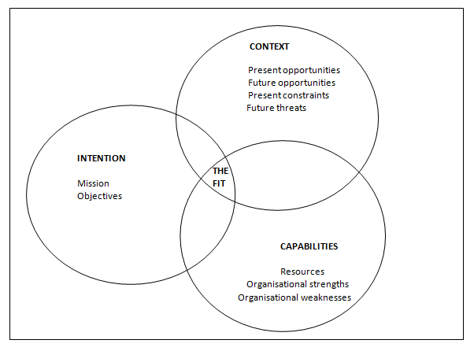

There are also variables in relation to the strategic planning (Dale, 2004)
- Identification and analysis of one or more problems
- Objectives
- Resources
- Organisation

____________________________________________________________________________

Figure 2 (Adaptation from Dale, 2004)
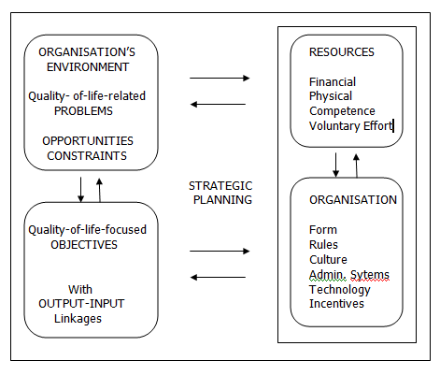

____________________________________________________

Planning Categories by Functional Level and Type of Area (Dale, 2004, pp 50-52)
- National Planning – may be broad-focus or delimited to administrative sectors, social groups, natural habitats, fields of production. It may be undertaken entirely at the national level, or it may be deconcentrated, to larger or lesser extent. The planning thrusts are basically national concerns, and the implementation of the resultant plans is the overall responsibility of national organisations.
- Regional Planning – may be undertaken at a specified regional level only (such as a province or a district), or it may be deconcentrated, more or less, to units below that level. Frequently, even if all the planning is done at the regional level, the plans may apply to only one part or some parts of the region, delimited by some criterion/criteria. Examples of such criteria may be assessed degree of poverty, certain ecological features, or a dominant land-use pattern.
- Local Community Planning – taken to mean any planning thrust that is wholly or mainly undertaken within the community itself. It may be done entirely through the local initiative and organisation or through interaction with one or more external bodies. It normally have an explicit emphasis on the quality of life people in the respective locality or localities.

_____________________________________________________________

Regarding the type of area
- Urban development planning – tended to emphasize physical planning of cities and other urban settlements. It then deals with the design of numerous urban facilities, commonly with reference to general standards of those facilities and their use. It is also based on some strategy analysis and related strategic planning , linking this aspects of design to more basic considerations of development.
- Rural development planning – it has been much – used term, in particular favour with donor agencies of programmes and projects in developing countries. Commonly, the focus and approach of rural development programmes and projects have intended to reflect loosely founded (or, at least, little elaborated and poorly documented) ideas of individuals involved, rather than the organisation-permeating conception of development. It has ranged from a very broad based (comprehensive) to highly selective thrusts, planning has spanned highly prescriptive and highly flexible modes of management have been applied.

__________________________________________________________

References
Dale, R. (2004). Development Planning. New York: Zed Books Ltd.
Siffin, W. (1991). The Problem of Development Administration. In Ali Farazmand
(ed.), Handbook of Comparative Development Administration (pp. 5-13).
New York: Marcel Dekker
Soltan, K. E. and Elkin, S. (1996). The Constitution of Good Societies. Pennsylvania: Penn State Press.

Todaro, M. (1997). Economic Development. (citation incomplete)

3
Goal Oriented Project Planning

Objectives

After this discussion, participants are expected to:
1. Discuss and explain a goal oriented project planning
2. Identify and evaluate problems that affect the overall development of their respective locality
3. Provide solutions and alternatives to the said problems
4. Construct and design a vision, goal, and objectives for their respective locality
5. Draft their respective goal oriented planning project

_______________________________________________________________________

Goal Oriented Project Planning (Based on Local Government Capacity-Building Handbook, 1991)

It is used in:
- Planning and replanning of interventions that will promote local government capability in resource allocation (distribution and management of resources)
- Team-building and human resource management (leading)
- Monitoring and controlling project activities (assessing performance and providing remedial actions when needed)
- Evaluation (assessing results and their contributions to the attainment of project purpose and overall goal)

GOAL-ORIENTED PROJECT PLANNING IS USED:
- To identify potential participants to a project
- To improve communication and cooperation between and among project participants through joint planning and clear project documentation
- To analyze the causes and effects of a given core problem
- To define realistic, definite, and sustainable project objectives
- To clarify the scope of responsibility of project participants
- To specify necessary project inputs/activities necessary to achieve results
- To provide sound basis for supervising projects, monitoring and controlling progress, evaluating impact and making appropriate changes, when necessary

______________________________________________________________________

GOPP IN LOCAL GOVERNMENT CAPACITY-BUILDING
- Identification of core problem, and relevant causes and effects in the areas of local development planning, local fiscal administration, personnel management, organization and management
- Formulation of hierarchy of objectives as well as provision of various options, including the most feasible one to carry out a local government capability-program or project
- Design of a local government capability-building project, including identification of relevant activities and inputs, and determination of expected project outputs/results as they contribute to the project purpose and overall goal
- Participation and team-building as an offshoot of the visualization process, thus promoting a better understanding between and among personnel in an organization or in organizational unit

STEPS IN GOPP
Phase I (Preparation)
- Organization of a Management Team
- Participation analysis
- Designation of moderator/facilitator
- Informing/mobilizing participants
- Moderator’s/facilitator’s preparation

_______________________________________________________________________

Phase II (Execution)
- Problem analysis
- Objective analysis
- Alternative Analysis
- Construction of a planning matrix
- Construction of the activities planning sheet

Phase III (Evaluation)
- Assessment of the Project Planning Management
- Assessment of Organization’s capability to implement the project
- Completion, adoption, and utilization of project planning management

HOW DO YOU UNDERTAKE PROBLEM ANALYSIS?
Step 1. Identify major problems existing within the stated problem situation (brain storming/identification of core problem)
Step 2. Write up a short statement of the core problem. Then, a brief substantiation is given each for each proposed core problem. Afterwards, the team agrees on the core problem, considering the interests and problems of the target persons, groups and institutions (e.g. Inadequacy of training programs for local officials)

_______________________________________________________________________

Step 3. Write up the cause of the core problem. Once the core problem is determined, then direct causes of the core problem are identified and placed parallel to each other under the core problem. The primary causes and subsequent causes are identified

CORE PROBLEM
CAUSES

Step 4. Write up the effect caused by the core problem. The substantial and corresponding effects of the core problem are placed parallel to each other above the core problem

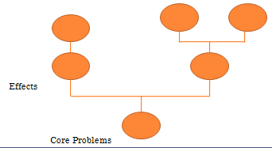

__________________________________________________________________

Step 5. Make a diagram showing the cause and effect relationship in the form of a problem tree

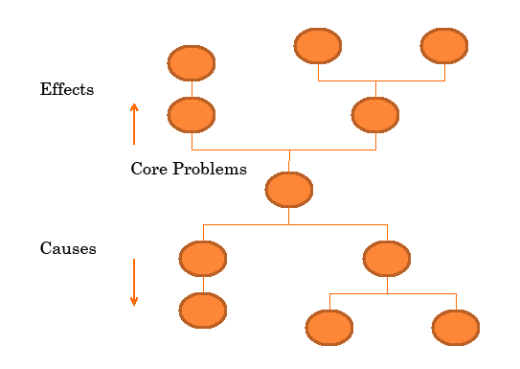

Step 6. Review the diagram as whole and verify its validity and completeness

_______________________________________________________________________

STEPS IN UNDERTAKING OBJECTIVE ANALYSIS
Step 1. Beginning from the top downwards, restate all negative conditions of the problem tree to positive conditions that are desirable and realistically achievable in the future (objective). Like the others, the core problem is also transformed into a core objective
Step 2. Transform the cause-effect relationships into means-ends relationships and examine to assure validity and completeness of the objective tree
Step 3. Draw the objective tree as an independent, separate overview. If necessary, revise statements or add or delete new objectives

OBJECTIVE TREE
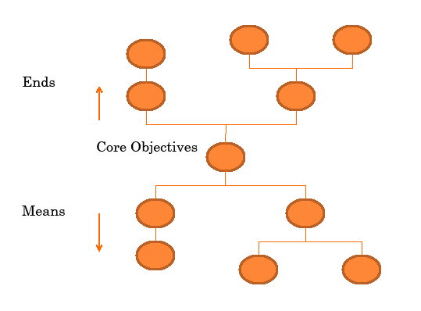

______________________________________________________________________________

ALTERNATIVE ANALYSIS

It involves the following procedures:
Step 1. Identify objectives which are perceived to be undesirable or not achievable
Step 2. Identify related “means-ends” branches in the objective tree. Means-ends branches constitute alternative solutions. Then, alternatives are marked or labeled with description, such as production approach, income approach, information, education approach
Step 3. Assess which alternative represents the best project strategy. This may be done by using certain criteria such as:
- Resource availability
- Political feasibility
- Socio-cultural desirability
- Goal/objective achievement
- Profitability indicators
- Social risk
- Time horizon
- Sustainability

_______________________________________________________________________

PROJECT PLANNING MATRIX
Why: a project is carried out (goals, purpose, and target group)
What: the project is expected to achieve (outputs)
How: the project is going to achieve these results (activities)
Which: external factors are crucial for the success of the
project (assumptions)
How: we can assess the success of the project
(objectively verifiable indicators)
Where: we will find the data required to assess the success of the project
(means of verification)
What: the project will cost (inputs)

___________________

Name: ______________________________ Date:_________
Department:__________________________ Time:_________
Undertaking Problem Analysis
Activity 2
Identify the core problem in your respective department. What do you think are
the causes of such problem?

CORE PROBLEM

CAUSES

___________________

Name: ______________________________ Date:_________
Department:__________________________ Time:_________
Undertaking Problem Analysis
Activity 3
What do you think are the effects of the Core Problem that you have identified in
Activity 2?

EFFECTS

CORE PROBLEM

___________________

Name: ______________________________ Date:_________
Department:__________________________ Time:_________
Undertaking Objective Analysis
Activity 4
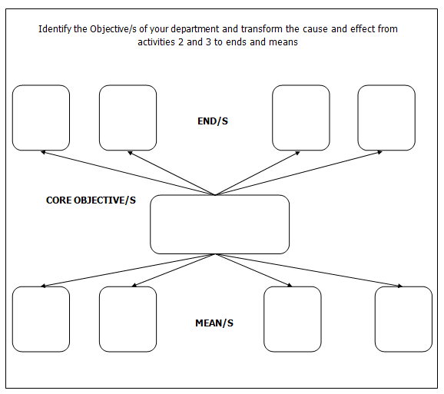
Reference
Sosmena, G. (1991). Local Government Capability building Handbook. Roxas Boulevard: LOGODEF

4
Guidelines for becoming a Successful and Effective Planner

Objectives

After this discussion, participants are expected to:
- Identify and analyze the steps of how to become a successful and effective planner
- Recognize their strengths and weaknesses
- Apply the steps of how to become a successful and effective planner to their respective offices or departments

_______________________________________________________________________

How to become a successful planner (Rodriguez, 1996)

Strengths of the Profession
1. Planners are the best comprehensive thinkers in the government today
- no other group in the government today is as well trained as planners think comprehensively, to synthesize complex problems, and to arrive at clear solutions while taking into account their short- and long-range effects. Planners can consider the needs of many individuals and groups, translating them so they are understood by both policy makers and the people that will be affected by planning decisions. And planners have access to high-level decision makers, enabling them to do good things for the community.
2. Planners need to know their strengths and weaknesses
- without this knowledge, strengths can’t be used nor weaknesses compensated for. Obviously, though the profession requires training in a wide range of disciplines and demands excellence in both written and spoken communication, not everybody can be well rounded and outstanding in all areas. But planners need to keep abreast of the field in general, and stay knowledgeable enough in their areas of expertise to command respect from peers and other professionals while doing a decent job in selling their recommendations to client.

_______________________________________________________________________

Advice and Guidance
1. Planners need to uphold the trust placed in them
- being trustworthy requires that one is first true to oneself. Planners are sometimes expected to be all things to people, and that is of course impossible. But this does not preclude using their leadership to try to address the needs of all people toward whom they are responsible from the poorest to the richest.
2. Planners need to remain flexible in their use of planning tools
- too often, planners will hang on to a comprehensive plan as if it has Biblical status that only they can interpret, and use it as the “tool to plan” – that is, as the way to control or manage development.
3. Planners need to be pragmatic
- for most part, such small decision by planners are made without political interference, following norms that have been the result of a comprehensive planning process.
4. Planners have to deal with politics
- planning, especially public planning, and politics are intrinsically intertwined. Sometimes planners twitch when the word politics is used in relation to public actions. Planners need to have a political savvy to use the system and work with politicians, without violating their principles, to benefit what they the people they serve.

_______________________________________________________________________

5. Planners need to become public relations expert
- public sector planners are no different than the other professionals who need to sell their products. But somehow, many public sector planners still think that they need only to prepare their plans as best they can and then wait for approval at hearings in which citizen will nominally participate. This old mentality, maybe the product of a formerly protected civil service status, now often fails.

The Ten Habits of Highly Effective Planners (Bernhardt, 1996)
1. Credibility: To care is to build trust
2. Listening: To Listen is to learn
3. Research: To research is to supplement, not supplant
4. Thinking: To process information successfully is to find solutions
5. Commitment: To be effective, planners must be committed
6. Continuing education: To grow is constantly to seek education
7. Decision Making: To build community requires making choices
8. Implementation: To implement a proposal is to show the community you care
9. Empowerment: To transfer responsibility is to build community
10. Responsibility: To build community requires community responsibility

__________________________________________________________

References
Berhardt, R. (1996). The Ten Habit of Highly Effective Planners. In McClendon, B.
& Catanese, A.J. (eds.). (1996). Planners on Planning. San Francisco:
Jossey-Bass Inc.
Rodriguez, S. (1996). How to Become a Successful Planner. In McClendon, B.
& Catanese, A.J. (eds.). (1996). Planners on Planning. San Francisco:
Jossey-Bass Inc.

